Resources for curricular development
I. Resources that are focused on the census:
Digital divide:
Hard To Count 2020: https://www.censushardtocountmaps2020.us/
Maps with overlays of hard to count areas – gives info about Internet access and cell phone data plans:
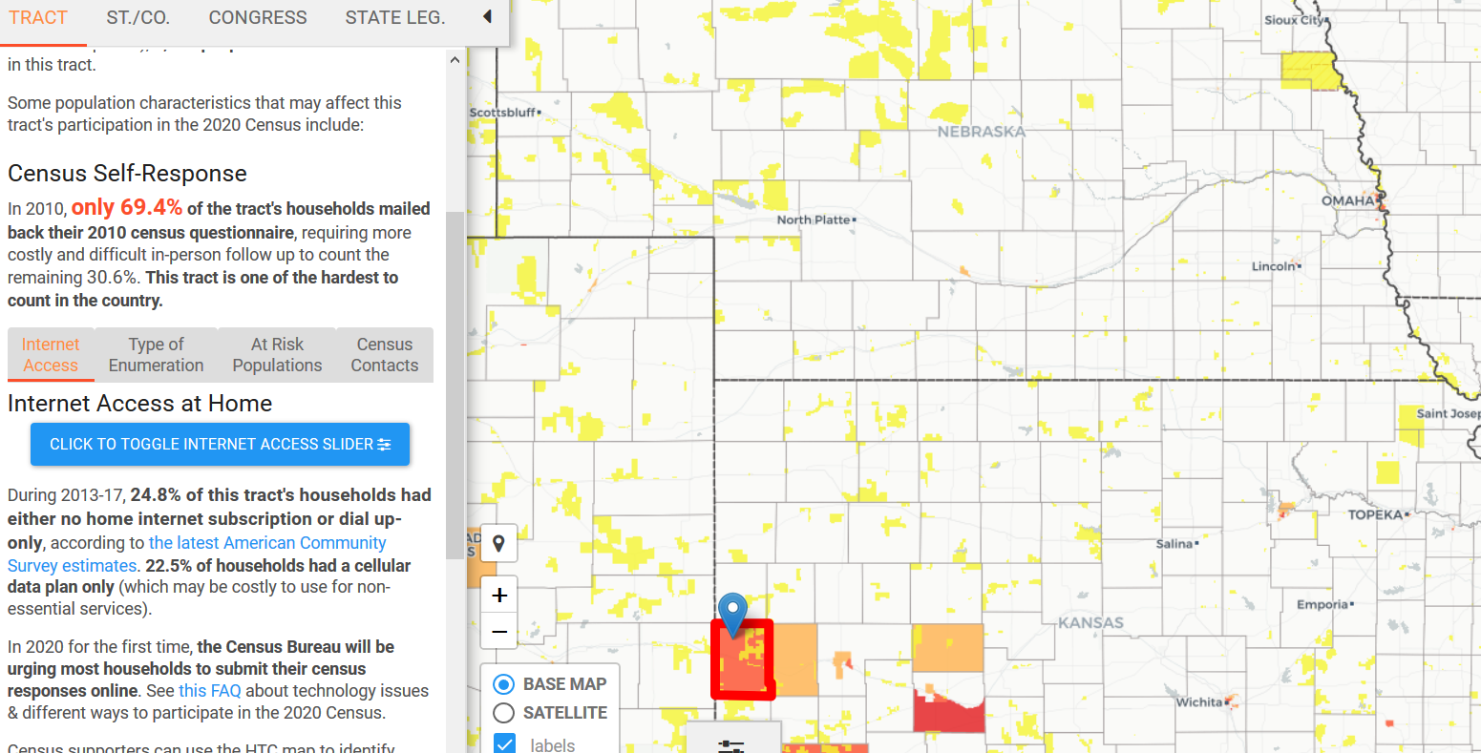
2020 Census Barriers, Attitudes, and Motivators Study Survey Report. Information on access to internet and preference for paper vs online surveys. This survey was carried out in 2018 in preparation for the 2020 census.
Education and equity
Counting for Dollars 2020
This site shows how federal money is apportioned based on the US Census, including Head Start and other education-related programs.
Census.gov https://www.census.gov/topics/education.html
The census site has several topical categories with specific reports, including education.
Health
Census.gov https://www.census.gov/topics/health.html
Data Visualization
US Census Bureau https://www.census.gov/programs-surveys/geography/data/interactive-maps.html
II. Resources that incorporate census data or are more tangential
Science, policy, health
GlobalChange.gov (https://www.globalchange.gov/)
Several of the reports include US Census data. The report below highlights how individuals in the Great Plains region may experience global climate change.
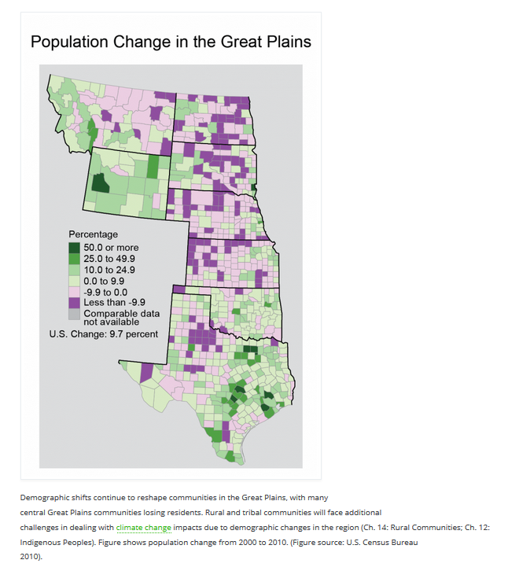

Series of public health and census articles in the American Journal of Public Health (August 2019, Vol 109, No. 8):
Census 2020—A Preventable Public Health Catastrophe

The US Census and the People’s Health: Public Health Engagement from Enslavement and “Indians Not Taxed” to Census Tracts and Health Equity (1790–2018)

On Choosing the Right Starting Question: A Public Health of Consequence

Maps

ArcGIS Census Tract: https://www.arcgis.com/home/search.html?t=content&q=tags%3ACensus%20Tracts&start=1&num=20

